Meridian NO. | SATC968 | OD | 241 | ID | 154.5 | Dia | 266 | Hub | 19×1-3/8”
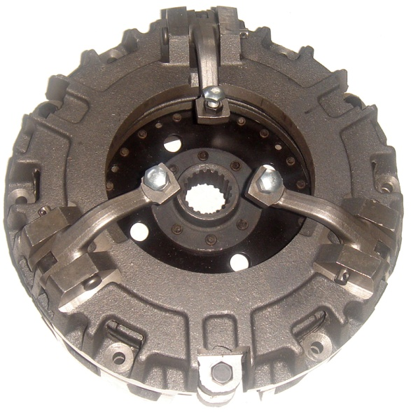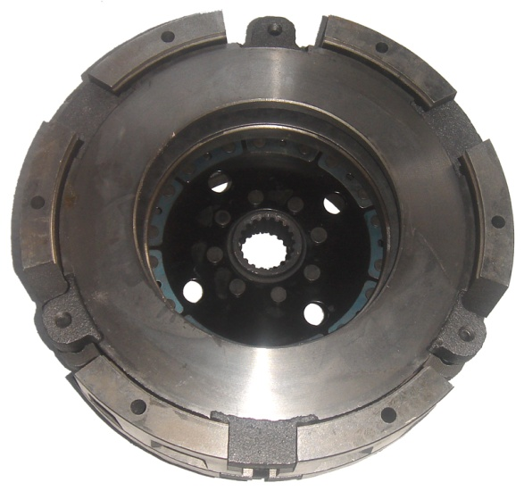
OE
R18376
Application
JOHN DEERE 850,870,900HC,950,970,990,1050,1070
SATOH 650 BISONZ,S670D,S750D
YANMAR 330,336

